Contents

Assignment Part 1 1

1: Import Dataset 2

2: Create a Simple Index 3

2: Query and Explain Function 3

3: Create a Complex Index 4

3: Query and Explain Function 5

# Assignment Part 1

## 1: Import Dataset

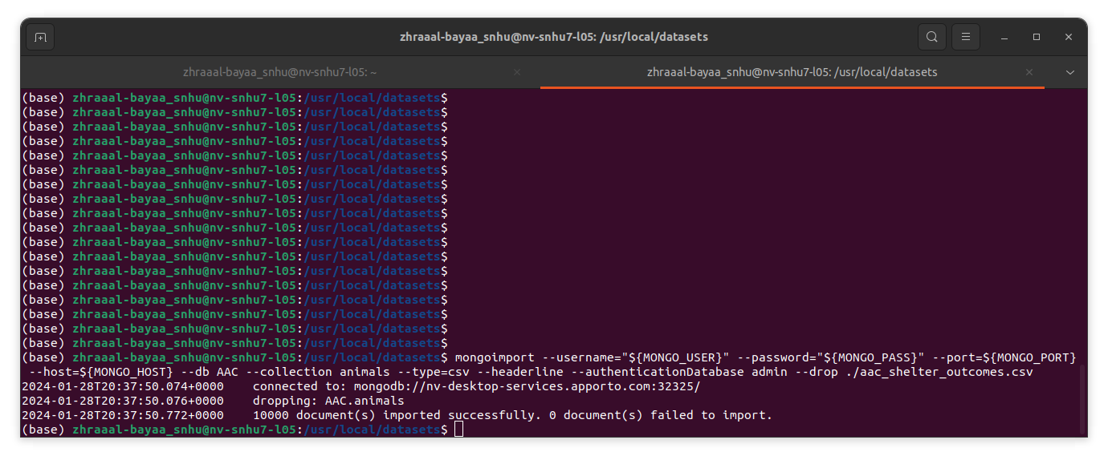

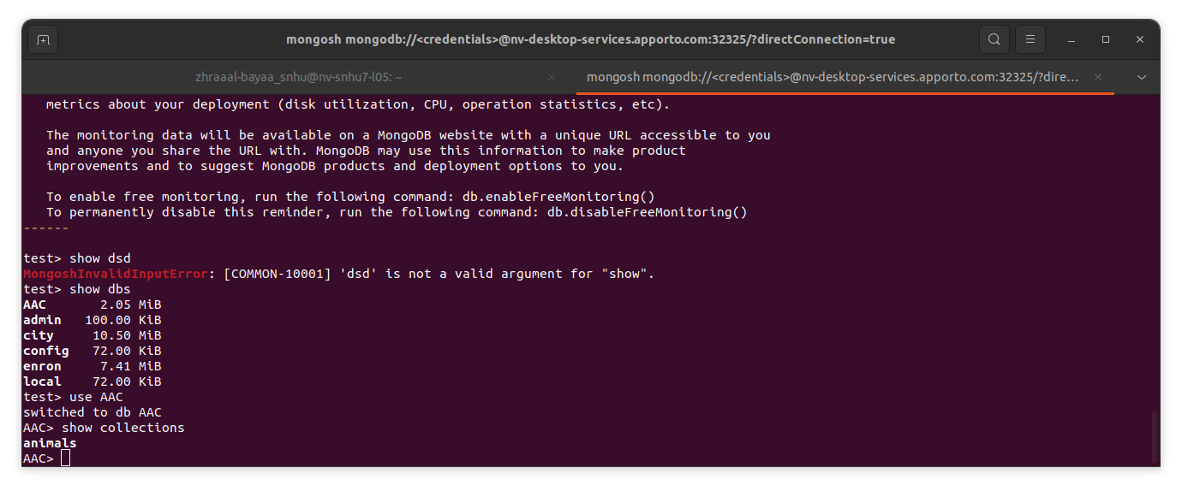

## 2: Create a Simple Index

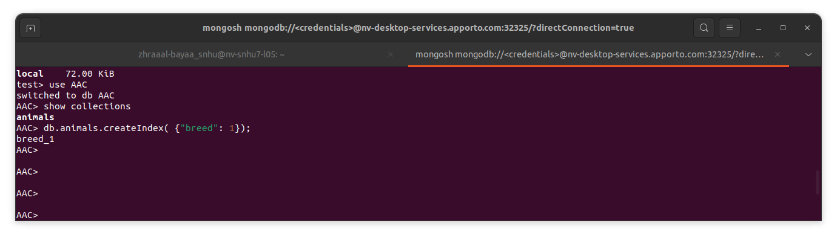

## 2: Query and Explain Function

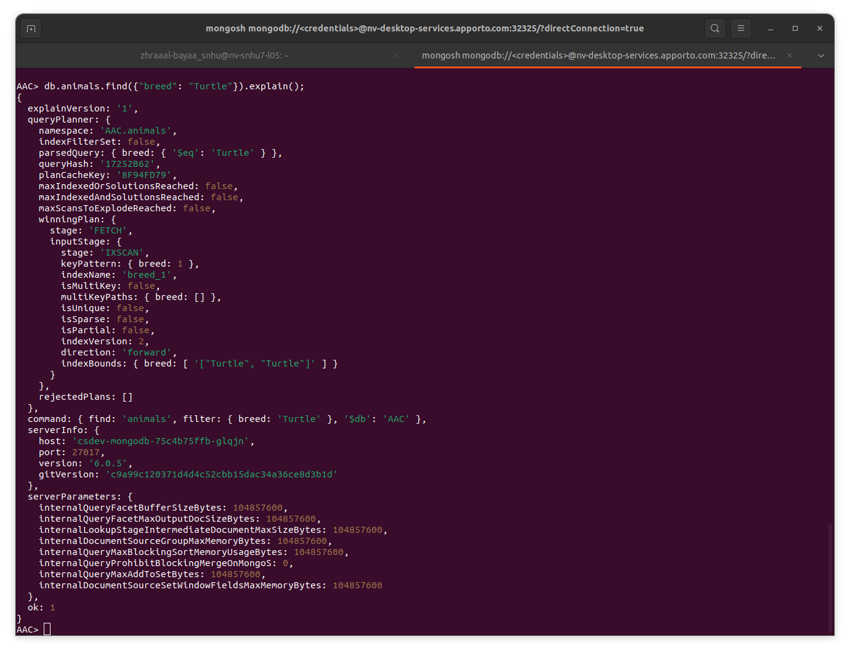

## 3: Create a Complex Index

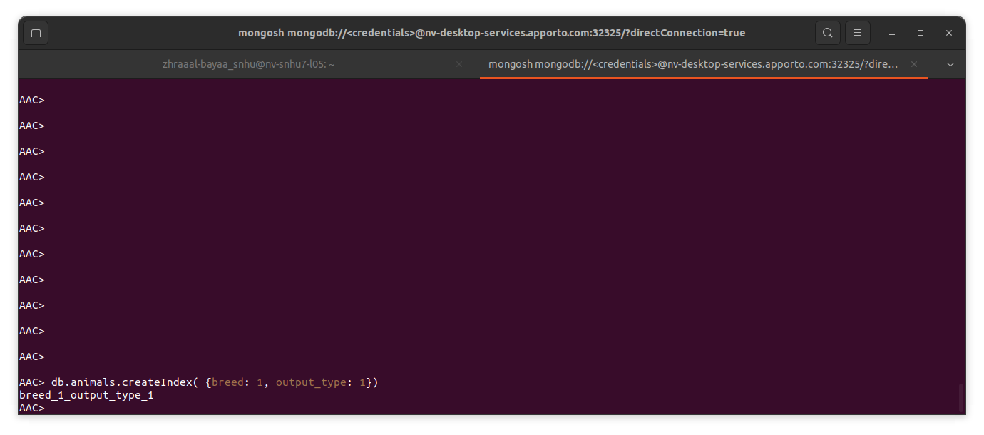

## 3: Query and Explain Function

